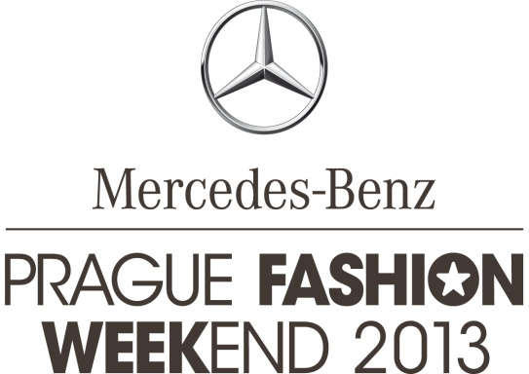

|  |  |
| --- | --- |
|  | Praha, 26. 9. 2013 |

Mercedes-Benz Prague Fashion Weekend 2013 presented an inspiring

programme, a lot of news and surprises

**Mercedes-Benz Prague Fashion Weekend ended on Sunday with the award ceremony of START-UP, young fashion designers competition. The evening al****so hosted guests from Malaysia. MBPFW took place on 18 - 22 September 2013 in a fashion tent in Parizska street, STUDIO in Salvátorská 8 and several other locations in the historic centre of Prague. The event attracted more than seventeen thousand people this year, and was enriched by the visit of a global fashion icon, Jimmy Choo, who came to Prague with his family. MBPFW 2013 was al****so visited by other foreign personalities and media representatives, mainly from Great Britain, Austria, Germany, Italy and Malaysia.**

Ribbon-cutting ceremony and official opening of the event Mercedes-Benz Fashion Weekend Prague was attended by the Mayor of Prague 1, Mr. Oldrich Lomecky and top models Simona Krainová and Viera Schottertová. Days full of fashion were officially launched on the 19th September at 3 PM in front of a fashion tent in the Parizska street. **Precious guest Jimmy Choo used only superlatives.** ***"I'm excited not only about Prague, the magical atmosphere and a pervasive quality of design, but of course also about Czech designers and beautiful young people. We travelled straight from London Fashion Week, and suddenly I'm here and I see this amazing and inspiring atmosphere."*** During his visit he met students of the Studio of Fashion and Shoe Design at the Academy of Arts and was a guest of honour at the final evening competition START-UP.

Markéta Martišková, student of the Royal Academy of Fine Art and Design Antwerp, has won the clothing category of START-UP. Talented designer receives a cash prize of 100,000 CZK. Markéta Šohajová, a student of Academy of Arts, Studio of Fashion and Shoe Design lead by Liběna Rochová, won the category of clothing accessories and was awarded with a cash prize of 50,000 CZK.

During its 4 days, Mercedes-Benz Fashion Weekend Prague presented 45 fashion shows on the main runway, while other ones took place on a small stage in the MBPFW STUDIO. The outfits were exhibited with a team of nearly fifty models, among which also actresses Linda Rybová and Ilona Svobodová, singer Yemi A.D. or top model Simon Kotyk, represented by CZ Models agency. Margita Skřenková led team of Maybelline make-up artists, while the REDKEN team of hairstylists worked under the lead of Mirka Hajdová, internationally acclaimed hairstylist currently living in London.

The accompanying programme hosted by a multifunctional space—STUDIO in Salvátorská - presented not only fashion shows on a small stage, but also workshops, discussion forums and a festival of Czech fashion films. The accompanying program was joined with an established sales festival designSUPERMARKET for the first time this year. STUDIO designSUPERMARKET introduced an exclusive selection of 25 designers with their own sales presentations. Furthermore there was an exhibition of fashion photographs finalists—ELLE Fashion Photo Award. The winners of the competition were announced at the opening press conference. Vojtěch Veškrna won the category of fashion photographer and Ondřej Janů fashion blogger category.

On the main catwalk we could see the art work presented by famous Czech and Slovak designers such as Kateřina Geislerová, Hana Havelková, Zuzana Kubíčková, Vladimír Staněk, Mirka Talavašková nebo Marcel Holubec W. Selection from the current collection of international brands such as Simple Concept Store, multi-brand boutique DUSNI3, brands LIST, s.Oliver and Tombolini were presented to the audiences. Saturday's gala evening, subtitled Prague meets Berlin introduced a new collection by Jakub Polanka named Belleville. The collection, inspired by ethnic themes of this Paris district, captivated audiences and garnered a well-deserved ovation. Michael Sontag, the acclaimed German designer, then presented his spring / summer 2014 collection characterized by his typical drapery and minimalism.

[**www.fashionweekend.cz**](http://www.fashionweekend.cz/)

[**https://www.facebook.com/Prague.Fashion.Weekend**](https://www.facebook.com/Prague.Fashion.Weekend)

**http://www.youtube.com/user/fashionweekendcz**

**Contact details for the media:**

Zita Vinšová

EV Communications

Mob.: + 420 602 367 721

Tel.: + 420 233 373 273

[vinsova@evcommunications.cz](mailto:vinsova@evcommunications.cz)

_________________________________________________________________________________________________________

**Basic information about Mercedes-Benz Prague Fashion Weekend 2013:**

**Date and venue:** 18.-22. 9. 2013, Fashion Tent at Pařížská street, Praha 1

**Title partner:** Mercedes-Benz

**Partners:** Czechoslovak Models, SONY, Canon, Decoland, InterContinental, Maybelline, REDKEN, Renomia

**Main media partners:** ELLE, Mladá Fronta with E15 and ZEN Magazín, Prima Ženy and JCDecaux

**Live streaming & news partner:** iconiq.cz

**Luxurious brands partner:** ONE magazín

**Media partners:** FashionTV Czech&Slovak, mdls.cz, Radio City, iLuxurylife.cz, TOP FASHION Magazín, Prague Exclusive, protisedi.cz, MAUDhomme

**Suppliers:** Papyrus, drawetc., Nespresso

Mercedes-Benz Prague Fashion Weekend 2013 is taking place under the auspices of Ing. Oldřich Lomecký, mayor of Městská část Praha 1.

[www.starscom.cz](http://www.starscom.cz/)