Viera Schottertová to be the face of Bratislava Fashion Weekend 2013
The biggest fashion event in Slovakia will bring about well-known names as well as a packed programme

Bratislava, June 14, 2013 – The face of the third annual Bratislava Fashion Weekend project is the Slovak top model Viera Schotterová, accepting the torch from Simona Krainová. Apart from one of the most successful models of today, fashion enthusiasts can look forward to some well-known names from the ranks of Slovak and foreign designers. Attendance has been confirmed by Fero Mikloško, Lukáš Kimlička, Marcel Holubec, and Lenka Sršňová. The fashion marathon will be here to enjoy from October 3 to October 6, 2013.

More space for fashion
Bratislava Fashion Weekend 2013 (BFW 2013) presents already the third annual round of the most prestigious fashion event in Slovakia. As well as its Czech counterpart, Mercedes-Benz Prague Fashion Weekend (MBPFW), it is organised by the Stars Communication company.

Also this year, the fashion shows will take place in a stylish tent with the capacity of 600 people located directly on the bank of Danube next to the EUROVEA shopping mall, which is also the main partner o the project. Compared to last year, the space for the presentation of fashion, beauty and style has grown even bigger – with an enlarged Fashion Lounge, newly added sales showroom and programme enhanced with various exhibitions and panel discussions.

New round, new face
For the communication of the Viera is one of the most successful Slovak models. In 1997, at the age of 15 she won a prestigious modelling contest that enabled her to get her foot in the door of the global modelling business. Soon afterwards she moved to New York where she spent 12 years. During her successful career she worked for globally recognised brands and as the only Slovak she was involved in more than 50 global campaigns including work for Chanel, Armani, Gant or Victoria’s Secret. Together with Karolína Kurková she is one of the only two Czech and Slovak models who received the invitation to be featured in campaigns for the Mango fashion brand.

‘Bratislava Fashion Weekend 2013 is after a long time the first Slovak project that I decided to endorse. I was convinced by its vision, mission and above all its high level of professionalism. I’m really glad that the format of a global fashion week has finally arrived in our region as well,’ Viera Schottertová, who is also the face of the Czech Mercedes-Benz Prague Fashion Weekend, commented on the cooperation.
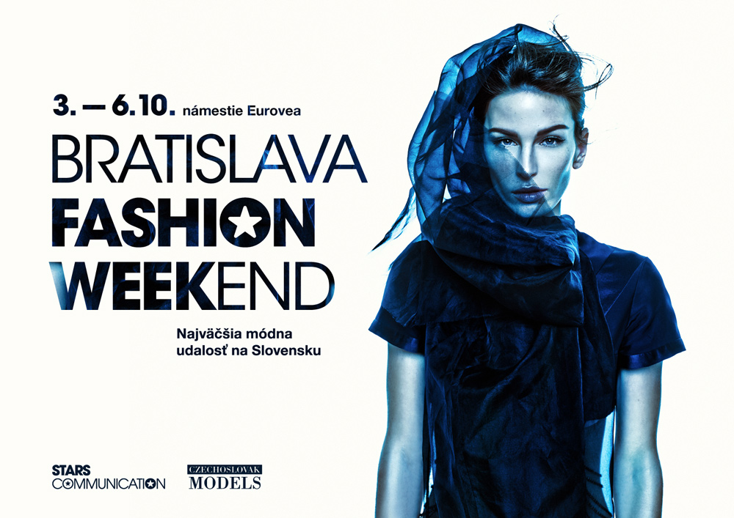
Viera’s styling for the key visual of BFW and MBPFW 2013 was provided by the project partners – in particular by the make-up artist Margita Skřenková on behalf of Maybelline and hair stylist Jana Burdová on behalf of REDKEN. The creator of the concept is the creative director of BFW and MBPFW, Olo Křížová; photographs are by Matúš Tóth. A behind to scenes video is available at www.youtube.com/user/fashionweekendsk
Fixed as well as rising stars
Similarly to all global fashion weeks, also BFW focuses on the support of the local fashion market, and therefore visitors may above all look forward to fashion shows of Slovak designers joined by well-known names such as Marcel Holubec, Petra Poórová, Lukáš Kimlička, Lenka Sršňová, and Fero Mikloško who attracted attention at the last annual BFW with his anniversary collection. ‘I will once again introduce two original collections to the audience of BFW 2013 – one for ladies and one for gentlemen, for the autumn and winter season. My fashion collections will be characterised by striking materials, layers and decorations. Of course, there will be also a surprise for our guests,’ says Fero Mikloško.

Apart from already established Slovak designers, also rising stars on the fashion heaven will get their chance to shine. The final evening of the BFW 2013 will be dedicated just to them. ‘An integral part of the BFW and MBPFW projects is a competition for young fashion creators entitled START-UP. Their creations will be presented directly on the catwalk both in Prague and Bratislava, making our vision of supporting young talents come true,’ says the creative director of BFW and MBPFW 2013, Olo Křížová. She adds: ‘Visitors will be inspired by foreign guests and well-known fashion personalities as well. There is definitely a lot to look forward to!’

Quick facts about BFW 2013:
Date and venue: October 3–6, 2013, Eurovea Square
Main partner: EUROVEA
Partners: Audi, Canon, L'Oreal Professionnel, Mattoni, Maybelline, Nespresso, Sheraton, SONY
Main media partners: EVA, Madam EVA, lesk.sk, diva.sk, TV Wau, Europa 2

BFW 2013 is organised under the patronage of the mayor of Bratislava, Milana Ftáčnik, and mayor of Bratislava – Staré mesto, Tatiana Rosová.
-END-
For current information about the continuing preparations of Bratislava Fashion Weekend 2013 please visit www.fashionweekend.sk or join us on Facebook at www.facebook.com/BratislavaFashionWeekend.
About the organizers:
The organisers of the third annual BFW and MBPFW are the renowned production company STARS COMMUNICATION and the modelling agency CZ MODELS. This partnership combines the professional background, long-time experience and contacts of both companies. For more information please visit www.czModels.cz and www.starscom.cz.

Media relations contact:

Zuzana Šimová
Phoenix Communication, s.r.o.
Slovakia | 811 08 | Bratislava | Cukrová 14
tel.: +421 2 5932 4354 | +421 904 816 167 | zuzana@phoenixcom.sk

